Project Design Phase
Problem – Solution Fit
Date | 5 September 2026
Student Name | Bantupalli Niharika
Project Name | Automated Network Request Management
Maximum Marks

Problem–Solution Fit
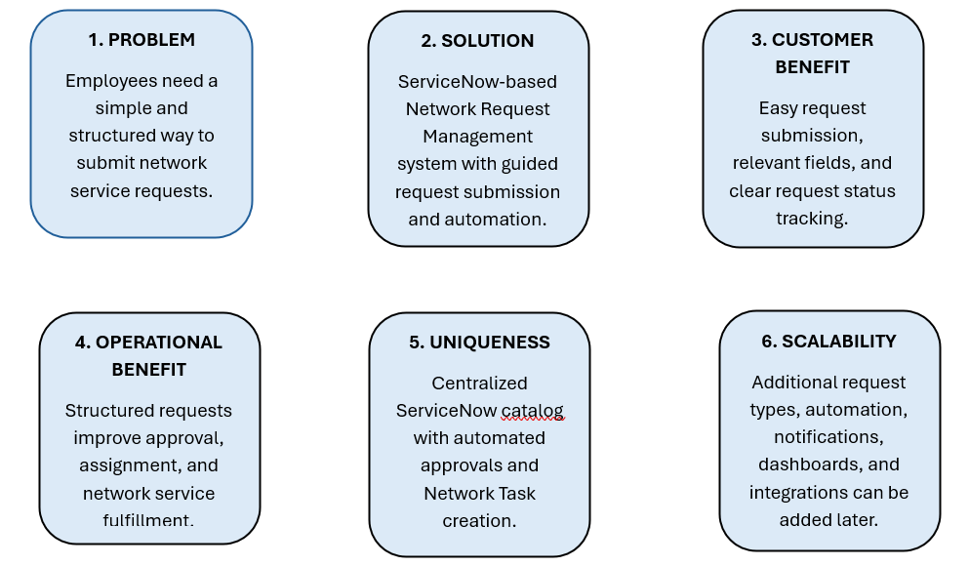

Figure 1: Problem–solution fit canvas for the Automated Network Request & Fulfillment Management project.

Parameter | Project Fit
Problem | Employees need a simple and structured way to submit network service requests.
Solution | A ServiceNow-based Network Request Management system with catalog-based request submission.
Customer Benefit | Guided request entry, relevant choices, and clear request status tracking.
Operational Benefit | Structured requests support efficient approvals, task assignment, and network service fulfillment.
Uniqueness | Combines ServiceNow Service Catalog with automated approvals and Network Task creation.
Scalability | Additional network request types, automation, notifications, dashboards, and integrations can be added later.

